Module Two Milestone

Anthony Lee

SNHU

[CS-330-T6633 Comp Graphic and Visualization](https://learn.snhu.edu/d2l/home/1116044)

Professor Brian Holbert

July 9, 2022

First thing: I spilt a drink on my desk and did not clean it up properly, I will not be including the mess on my black glass desktop.

The objects that I will be creating in 3D are the drink can, hitbox (my arcade stick for fighting games), portable charging brick, and the desktop for the plane. The drink can is made up of a cylinder which is a good object to design in my opinion. My hitbox has multiple shapes on a cuboid, which is the object with multiple primitive shapes, and my charging brick can be the simple cuboid.

My black glass desktop, which is a plane, I will change the color to something other than black if that is an option so it can contrast better with my objects. I wanted a mono-color background for the plane because it is easier to code, and my glass top surface is smooth which is also easy to code. I am omitting the monitor, tagboard, and wires as they are not the objects I want to focus on. I will also not make the surface a reflective surface.

One last note about my hitbox, there are 21 cylinders, 12 spheres, 1 cuboid, and 4 tori on a cuboid. I will not be including the acrylic design plate that is on top because I do not think clear objects will look good with light reflecting off it.

For my drink can, I think I will not do the design on the can partly for copyright and partly for ease. However, I think I will use a simpler design that wraps around the can. I will make the can into only a cylinder with no tapers, but the drink can’s opening and the ring tab will be ellipses.

The front view

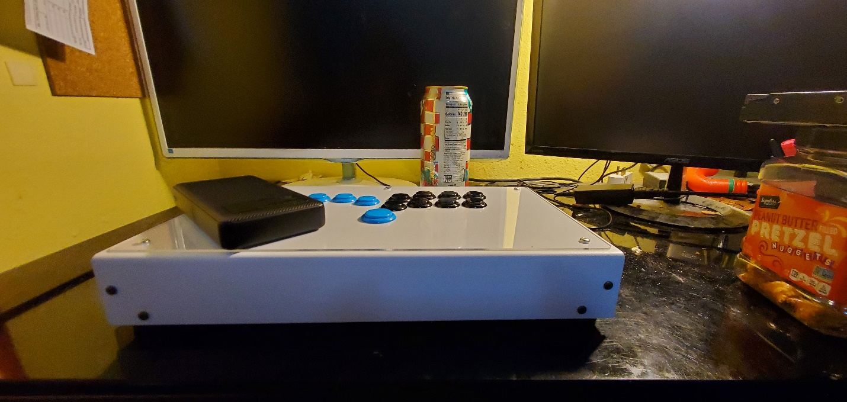

Plane

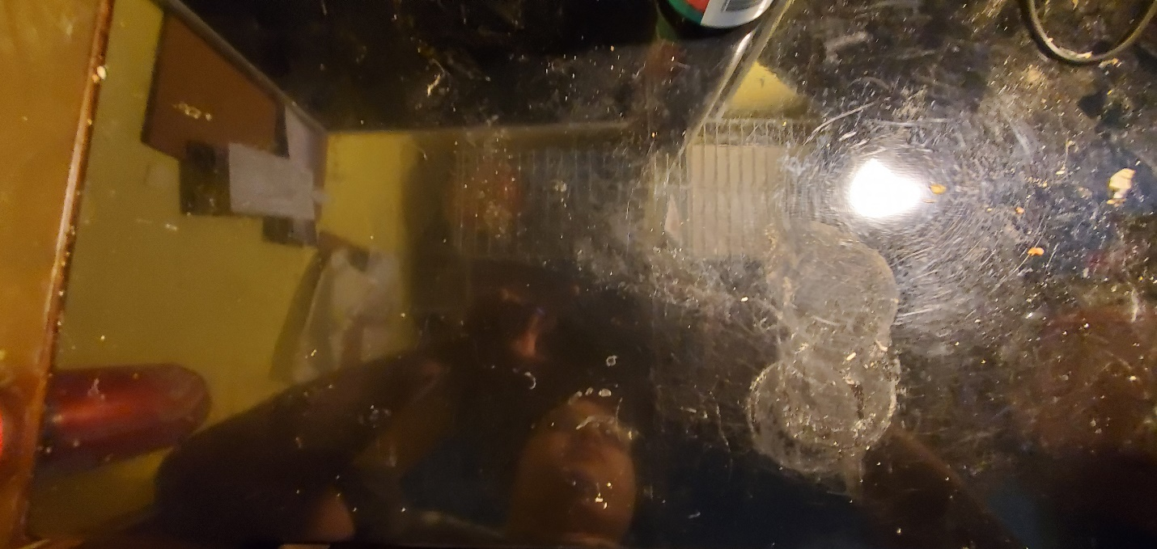

Top-down view

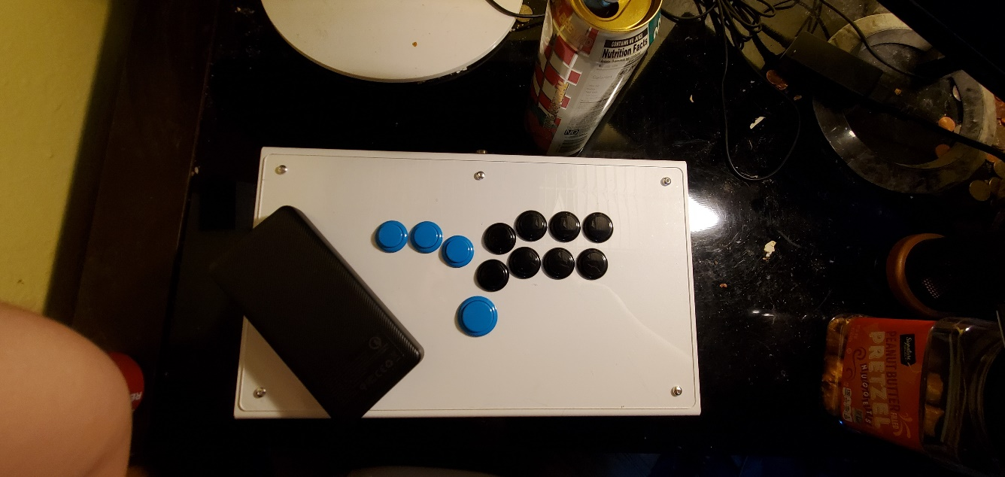

Back side of hitbox

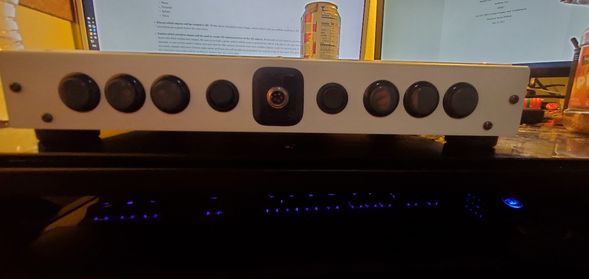

Bottom view of hitbox

